***Storm and Climate Data Record (SCDR)***

Implementation Plan

Date of record:

Jan 1, 2017 to Dec 1, 2019

Principal Investigator: Ashley Littles

## I. Introduction

### 1.1 Overview and purpose

I have created a Storm and Crime Data Report as requested by the police department to determine a correlation between weather storms and crime. Detectives from the police department reviewed the report and now have some new information. The police department has moved on to investigating the crimes as well as the rising cost of crimes during storms. This new report will give the detectives updated information that will predict the next possible string of crimes.

### 1.2 Define why you need data analysis

Data analysis is important to determine if the rise in cost of crimes is in relation to when there is a storm. We can utilize this data to make future predictions on new crimes and the police department can put preventative measures in place. The raw data can be sourced from the city of Miami data set from Jan 1, 2017 to Dec 1, 2019 during the storm events.

## II. Data Preparations

### 2.1 Name data sources

The data sources originate from a city of Miami data set between Jan 1, 2017 and Dec 1, 2019 showing crimes that occurred during storm events.

### 2.2 Filter through unnecessary data

In this data set there are a few pieces of data that are deemed unnecessary. The unnecessary data is what kinds of crime occurred. Knowing what kind of crime happened doesn’t pertain to the rising costs in crimes during the storms.

### 2.3 Define your parameters

The parameters are victim loss from crimes, the crimes that occurred during the storms, and the crimes that occurred without a storm being present.

### 2.4 Identify measurement priorities

To properly measure the data for analysis, we must prioritize certain areas of the data. The areas of the data that are needed to measure are the crimes that happened while there was a storm present, the crimes that happened without there being an active storm, victim loss from the crimes, and the locations of all the crimes that happened.

### 2.5 Ensure collected data fits the need

To ensure that the collected data fits the need for the report it must show how much money has been lost during the storms and when there is not an active storm. The current collected data does fit the need for this specific information.

## 

## III. Data Analysis

### 3.1 Identify scripts used

The scripts that were used to create the graph visualization:

install.packages(“tframe”);

install.packages(“tfplot”);

library(“tframe”);

library(“tfplot”);

setwd(“C:/Users/Public/Desktop/DAT-375”)

crimestormdataQ <- read.csv(“crimeStormQ.csv”)

print(crimestormdataQ)

crimenostormdataQ <- read.csv(“crimenostormQ.csv”)

print(crimenostormdataQ)

z<-ts(cumsum(crimestormdataQ$Loss)/1000,start=c(2017,1), frequency=12)

x<-ts(cumsum(crimenostormdataQ$Loss)/1000,start=c(2017,1), frequency=12)

Tfplot(z,x,

ylab=”Victim Loss in K$”,

xlab=”By Month by Year”,

title=”Victim Loss From Crimes for Jan 2017 – Dec 2019”,

subtitle = “Cumulative Loss in Thousands of Dollars”,

legend=c(“Crimes During Storms (black)”, “Crimes When No Storms (red)”),

source=”Source: DAT Data”)

### 3.2 Run the scripts to analyze the data and validate the output

After running the scripts, we received a line graph as the output. We are able to use this line graph to analyze the data. The line graph that was created validates the data by displaying the victim loss amount from crimes, the number of crimes that occurred during the storms and number of crimes when there is not a storm present. Looking at the graph, we see the cumulative data by month and year. This allows for us to get a great overview from Jan 2017 to Dec 2019. We can see that the amonunt of victim loss rapidly increases as the crimes during storms increase and the amount of victim loss very slowly and steadily increases when crimes occur during no storms.

## IV. Drawing Conclusions

### 4.1 Present the results of the analysis to stakeholders

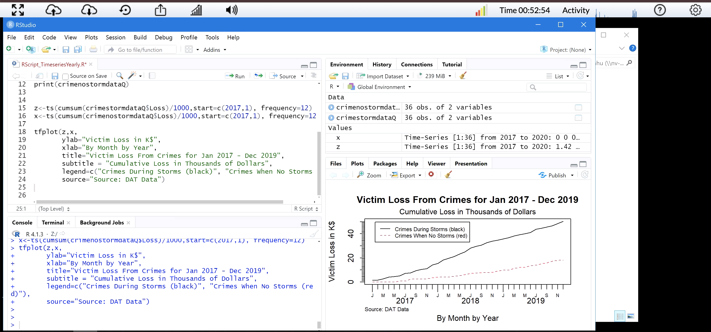

We have recieved updated data from the Miami police department about the crimes during storms and the rising cost of crimes while there is a storm present. Specifically, we are analyzing the victim loss from crimes during storms and when there are no storms from Jan 2017 through Dec 2019. As the crimes during storms increased so did the amount of victim loss as you can see with the black solid line. When there were no storms there was still a steady increasing rate of crimes, but the victim loss was not as much compared to the victim loss when storms are present as you can see with the red dashed line on the graph.

### 4.2 Determine whether the problem was addressed, including any challenges and limitations

The problem is does the amount of victim loss due to crimes increase while storms are present compared to when no storms are present. After the performed analysis the problem was addressed. The results from the analysis created a line graph that shows the victim loss from crimes during storms and when there are no storms from Jan 2017 to Dec 2019. This line graph addresses the problem by confirming that the amount of victim loss does increase significantly due to crimes during storms. There are a few limitations with the graph such as the type of storms that have occurred and if that has any effect on crimes committed. Also knowing the areas where the storms were present. The storms could have occurred in an area already known for higher rates of crime.

### 4.3 Report potential new findings

Analyzing this new set of data has allowed for new information to be found as well as new strategies for the Miami police department. By looking into if victim loss increases because of crimes when a storm is present, we are able to determine the exact amount of loss that has happened and if crimes indeed increase when there is a storm. Finding this new information can allow the Miami police department to issue out more patrols while a storm is occurring.

The department can also figure out other preventive measures with the new findings. The graph also shows that there was a larger increase from 2018 onwards. The Miami police department can check the crime records during that period to see what could have caused this increase as well as look into what weather storms occurred in 2018. Typically, during major storms such as tornados or hurricanes residents are asked to evacuate for their safety causing them to leave a lot of their belongings behind. This poses a perfect opportunity for criminals to raid homes causing the victim loss to greatly increase. The Miami police department could release patrols for a certain amount of time after a storm has happened to protect the abandoned homes from theft.